Below are the SCOM alerts sent. Best I could do cutting and pasting in excel. Date and time gets truncated.



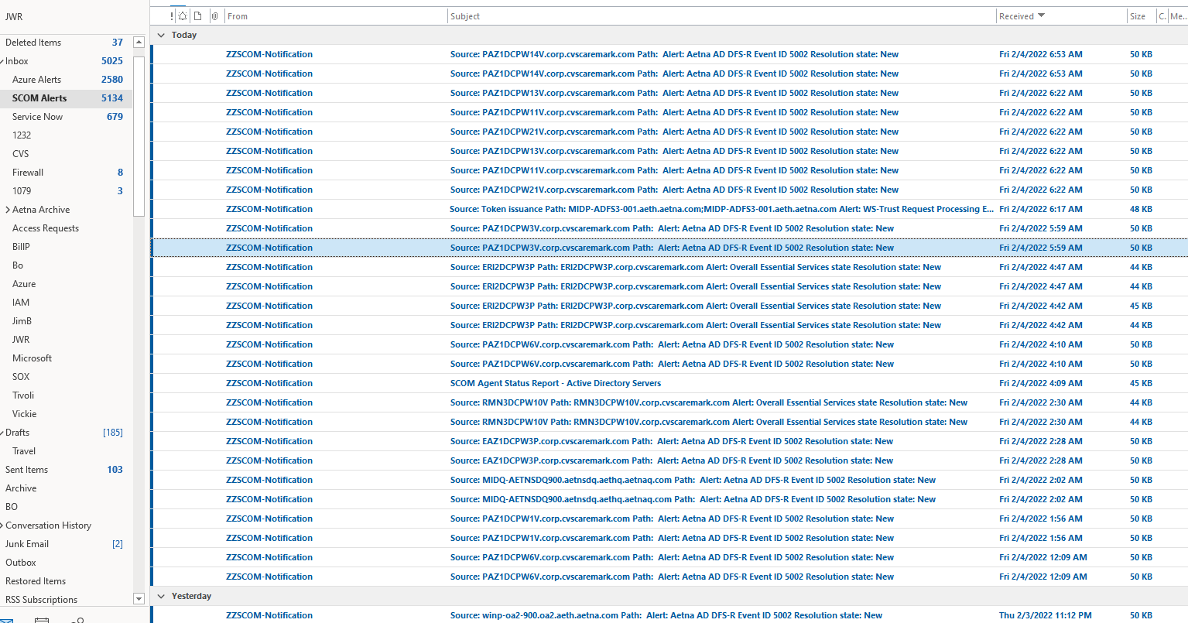

We cannot track Tivoli alerts. They get send to the individual on-call person. I showed you an example of one I received in previous documentation.

Items that we had actions on have a change ticket associated. There are no other items that we acted on in the listed SCOM alerts other than ones that are associated with the change records where we resolved them

